Design Relational Storage

Requirements  
Tailwind Traders is looking to move their existing public website database into Azure, as the  
website front end is being moved there as well. The website front end will initially only be  
deployed in 2 regions for redundancy. However, it is expected that as traffic increases the  
website will be replicated to other regions around the world. The database, which you are  
being asked to migrate, holds the product catalog, and all online orders. Currently the database runs on a single Microsoft SQL Server Always On availability group on premises.

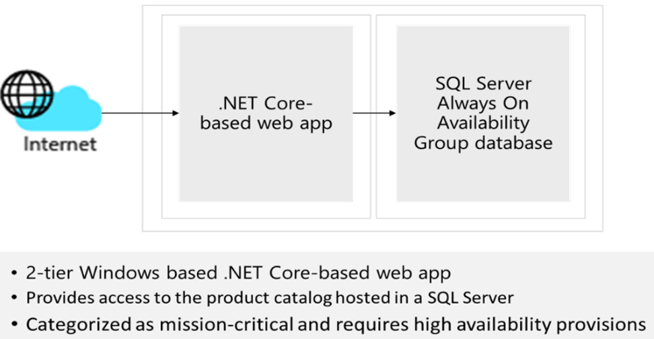

Primary concerns of Tailwind Traders:

* **High availability.** A primary concern for Tailwind Traders is that this database be highly available as it is critical to their business. Any outages may result in lost sales or  
  customer confidence.
* **Website performance.** While the performance of placing orders is normally  
  satisfactory, browsing or searching pages with many items listed is reported as being  
  “sluggish.”
* **Security.** Tailwind Traders is very concerned about personal or financial information  
  stored in the database being exposed. In addition to implementing proper security  
  measures, the security team needs to verify that industry standard best practices are  
  implemented, when possible.

Tasks

1. Design the database solution. Your design should include authorization, authentication, pricing, performance, and high availability. Diagram what you decide and explain your solution.